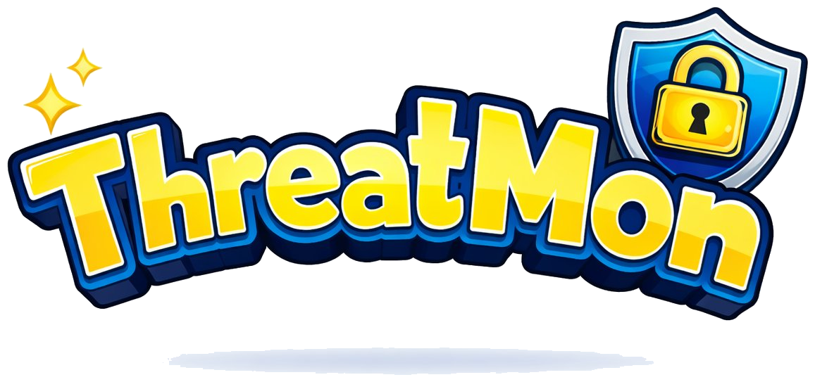
CLASSROOM · TEACHER RESOURCES
Teacher's Guide
A Defender's First Mission
Grades 3–5 · 30-minute lesson · Careers, defender skills, threat literacy
PLAY THE GAME · threat-mon.com/kids
Free · No login · No data collection · Works on any device

Lesson at a Glance
Title: Meet the Cyber Villains: A Defender's First Mission
Essential question: Who protects the computers we use every day, and how do they do it?
Big idea: Real people have a real job called cyber defense. Villains try tricks; defenders have power moves that stop them. The moves you learn today are the same ones grown-ups use to protect hospitals, schools, and families.

Learning Objectives
By the end of class, students will be able to:
- Name at least two real jobs that protect computers and the internet.
- Identify three "power moves" defenders use: Strong Lock (passwords + MFA), Fix the Holes (updates), and Spot the Trick (phishing awareness).
- Describe, in their own words, why cyber villains try to break into computer systems.

Standards This Lesson Supports
- ISTE Students 1.2 – Digital Citizen: Students recognize safe, legal, and ethical behaviors when using technology.
- CSTA 3-5.NI.06 – Networks & the Internet: Discuss real-world cybersecurity problems and how personal information can be protected.
- Common Core ELA – SL.4.1 / SL.5.1: Engage effectively in collaborative discussions.

Materials
- One device per student or per pair (Chromebook, tablet, or laptop) with browser access to threat-mon.com/kids
- Projector or smartboard to demo gameplay and show villain portraits
- Three "Power Move" posters or slides (see Appendix A)
- Exit ticket — one per student (see Appendix B)
- No-screen backup: printed villain and power-move cards from the Card Deck PDF (Appendix C)

Pre-Teach Vocabulary
Introduce these four words in about 90 seconds before starting the lesson flow.
Cybersecurity — Keeping computers, phones, and information safe from people who want to harm them.
Defender — A person whose job is to protect computers and networks. Real defenders work at hospitals, schools, banks, and even the military.
Cyber villain — A person or group that tries to break into computers to cause harm, steal information, or demand money. (In real cybersecurity, these are called "threat actors.")
Impersonate — To pretend to be someone you're not so people will trust you. Many cyber villains impersonate help desks, bosses, or friends to trick their victims.

30-Minute Lesson Flow

Minutes 0–3 · Hook
Open with: "Raise your hand if you used a computer, tablet, or phone today. What did you use it for?"
Take 2–3 answers. Then ask:
"What would happen if someone broke into it and locked you out, or read all your messages?"
Let students react. Land the point:
"Real people have a job protecting computers from that. They're called cyber defenders. Today you're going to be one."

Minutes 3–8 · Mini-Teach: Tricks vs. Power Moves
Do this part before students open the game. Project one villain portrait from the Card Deck (Cozy Bear or Sandworm are good openers — visually striking but not scary).
Say:
"This is a monster we're going to meet in our game today. But she's based on a real group of hackers. Their trick is sneaking into computers and quietly reading messages for months. Your job — and the job of a real cyber defender — is to stop them. Your guide in the game is Professor Chen, the head of the Cyber Defender Academy."
Introduce the three power moves with kid-friendly analogies:
- Strong Lock — Passwords plus multi-factor authentication. "Like needing a key AND a secret password to open the door."
- Fix the Holes — Software updates. "Like patching a leaky roof before a storm."
- Spot the Trick — Phishing awareness. "Not every message is from who it says. Real defenders check twice."
Write the three power moves on the board. Tell students: every time they beat a villain, they'll see which power move worked — their job is to remember them.

Minutes 8–23 · Gameplay (15 minutes)
Setup (2 minutes): Have students open threat-mon.com/kids on their devices. Briefly demo one battle on the projector.
A heads-up about the name prompt: The game asks students to pick a defender character and a name. Tell them first name only, or make one up — the game saves progress in the browser only and sends nothing to a server, but it's good practice.
Play (13 minutes): Students play in pairs, taking turns. The goal is to beat all 9 villains, including the Nation State Apex final boss, to earn a printable Certificate of Completion.
Teacher's job during play: Circulate. Ask prompting questions:
- "Which power move did you try first? Why?"
- "What trick did this villain use?"
- "Could you stop this same trick at home?"
Watch for: students picking moves randomly. If you see it, pause their pair and ask: "What's this villain's trick? Which power move is the best match?" Teach them to read before clicking.

Minutes 23–28 · Class Whip-Around
Each pair shares in one sentence:
- Which villain they fought
- Which power move worked
- Why it worked
Keep a tally on the board of how many pairs used each power move. The tally makes a visible point: defenders use these same moves every day, all over the world.
End with the career beat:
"Every power move you used today is something real cyber defenders do at hospitals, schools, banks, and even the military. Some defenders are only a few years older than you. This could be your job one day."

Minutes 28–30 · Exit Ticket
Hand out Appendix B. One question:
Name one power move you would use to protect your family's devices at home. Why?
Collect on the way out. These become your formative assessment and a great hallway bulletin board.

Differentiation
Faster finishers: Elementary students vary widely in pace, and a confident 4th or 5th grader may finish the base game in 8–10 minutes. When they do, route them to one of these options:
- (a) Replay in Perfect Run mode — hit Start Over and try to beat all 9 villains without a single wrong answer.
- (b) Switch to the printed Card Deck — pair them with a classmate who hasn't finished yet, and have the fast finisher quiz their partner.
- (c) Defense-in-Depth challenge — ask them to pick any villain and name all three power moves they could use against it, and explain which is primary.
Struggling readers: Pair with a strong reader. Offer a printed vocabulary card to keep at their station. During the whip-around, let them point at the power-move poster instead of saying it aloud if they prefer.
No-screen option: The entire lesson works as a card game. Use Appendix C cards: one student plays the villain and reads the trick, the other plays the defender and picks a power move. Swap roles.
English learners: The three power moves lean on pictures and analogies for a reason. Make sure each poster has an image (a lock, a bandaid on a roof, a magnifying glass). Pre-teach "lock," "hole," "trick," and "impersonate."

Framing Notes for Teachers
Please read this section before teaching.
IMPORTANT FRAMING GUIDELINES
Don't dwell on nationality. The real APT groups in the game come from many countries. For this age, focus on behavior ("this group sneaks into networks"), not identity ("Russian hackers," "Chinese hackers"). This keeps the lesson focused on cybersecurity and protects students whose families may come from those regions.
Keep it empowering, not scary. If a student gets anxious ("Is this happening to my mom's computer?"), redirect to the power moves: "That's why defenders — and now you — know how to stop it."
Ransomware question. If a student asks what some villains do: "Some villains lock up a school's or hospital's computers and ask for money to unlock them. That's why defenders keep backups and strong locks." Don't go deeper.
Don't glamorize. The villains are obstacles, not cool outlaws. Language matters — "villain" and "defender," not "hacker" and "hero hacker."
If something goes wrong in-game (stuck, frozen, inappropriate content somehow surfacing), stop that pair, switch them to the card-game backup, and continue.

Discussion Extension Questions
Use these if you have extra minutes, or as a follow-up journal prompt.
- If you designed a new cyber villain, what would its trick be? What power move would stop it?
- What's one device in your house that needs a defender?
- Who do you tell if you see something online that feels wrong or scary?
- What's the difference between a trick and a lie?

Career Connection Facts
Drop one or two of these during the wrap-up:
- There are over 700,000 unfilled cybersecurity jobs in the United States right now. (Check CyberSeek for current figures.)
- Cyber defenders work at hospitals, schools, banks, sports teams, video game companies, and space agencies.
- Some defenders start by joining their school's CyberPatriot team in middle school.
- You don't have to be a "math person" to be a defender. Many defenders say the best skill is curiosity — noticing when something looks off.

After the Lesson

The In-Game Certificate
When students beat all 9 villains — including the Nation State Apex final boss — the game awards a printable Certificate of Completion signed by "Professor Chen, Academy Instructor." Students can print it or screenshot it to take home. It's a great artifact for a hallway bulletin board or to show parents.

Privacy Note for Administrators
ThreatMon Jr (threat-mon.com/kids) collects no student data. There are no accounts, no logins, and no server-side tracking. Student progress is saved only in the browser on the device they played on. This is safe for classroom use without parental consent forms.

For Students Who Got Hooked
- CyberPatriot ESCEI — Elementary School Cyber Education Initiative, free, built for grades K–6.
- CYBER.ORG K-12 Curriculum — free, standards-aligned, funded by CISA.
- CISA Cybersecurity Awareness for Kids — posters, videos, activities.
- Girls Who Code Clubs — free after-school clubs with a cyber track.

For the Teacher
- GenCyber — free summer professional development for K–12 teachers, funded by NSA/NSF.
- CYBER.ORG Range — free classroom-ready labs for older grades if students want to keep going.

Appendix A · Power Move Posters
Print at 11×17 for classroom walls, or project as slides. Template blocks below.

STRONG LOCK
A key AND a secret password.
What it is: Strong passwords + Multi-Factor Authentication (MFA).
Stops: Villains who guess or steal passwords.

FIX THE HOLES
Patch the roof before the storm.
What it is: Keep software updated. Don't run old versions.
Stops: Villains who sneak in through cracks in outdated software.

SPOT THE TRICK
Not every message is from who it says.
What it is: Check twice. If something feels off, ask a grown-up.
Stops: Villains who fool people into clicking bad links or sharing passwords.

Appendix B · Exit Ticket
Print one per student. Collect on the way out the door.

ThreatMon Exit Ticket
Meet the Cyber Villains: A Defender's First Mission
Name:
Date:

The power move I would use to protect my family's devices at home is:

Here is why I picked it:

Appendix C · Card Deck (No-Screen Version)
The companion Card Deck PDF (threatmon-cards-grades-3-5.pdf) contains 9 villain cards, 3 power-move cards, and a teacher answer key. Print on card stock and cut along the crop marks.

What's in the Deck
- 9 Villain Cards — one trick per villain, written at a grade-3-5 reading level. 8 villains map to one primary power move; the 9th is a final boss that requires all three.
- 3 Power Move Cards — Strong Lock (blue), Fix the Holes (amber), Spot the Trick (red). Print one set per pair of students.
- 1 Teacher Answer Key — color-coded, includes a "Teaching Tip" about secondary defenses. Keep this page off the student tables.

How to Play
- One student draws a Villain Card and reads the trick out loud.
- The other student picks the Power Move card that stops it, and explains why in one sentence.
- Check the Teacher Answer Key. First pair to correctly match 3 villains wins the round.
- Save the Nation State Apex (Final Boss) card for last — it requires all three power moves to beat.

Match Key (Teacher Reference)
VILLAIN | THE TRICK (SHORT) | POWER MOVE
SCATTERED SPIDER | Fake IT help-desk calls | SPOT THE TRICK
COZY BEAR | Stolen passwords, stays hidden | STRONG LOCK
LAZARUS GROUP | Exploits old software | FIX THE HOLES
FANCY BEAR | Guesses weak passwords | STRONG LOCK
SANDWORM | Attacks unpatched systems | FIX THE HOLES
VOLT TYPHOON | Hides in old routers | FIX THE HOLES
FIN7 | Fake email attachments | SPOT THE TRICK
LAPSUS$ | Tricks workers for passwords | STRONG LOCK
NATION STATE APEX | Uses every trick at once (FINAL BOSS) | ALL THREE

TEACHING TIP · DEFENSE IN DEPTH
When a student picks the "wrong" power move, don't say they're wrong — ask them why they picked it. Often they've spotted a real secondary defense (e.g., MFA would help against phishing even if Spot the Trick is the primary answer). That's great thinking — it's the same reason the Nation State Apex boss card requires all three. Real defenders layer their defenses because no single move catches every villain.

Appendix D · Standards Crosswalk
Quick reference for administrators and curriculum coordinators.
STANDARD | HOW THIS LESSON MEETS IT
ISTE 1.2.d — Digital Citizen | Students practice safe technology behaviors and identify protective actions.
CSTA 3-5.NI.06 | Students discuss real cybersecurity problems (APT tradecraft at age-appropriate depth) and protective measures.
Common Core SL.4.1 / SL.5.1 | Pair play + class whip-around require collaborative discussion and one-on-one reasoning.
CASEL — Responsible Decision-Making | Students evaluate which power move best fits a threat scenario.

